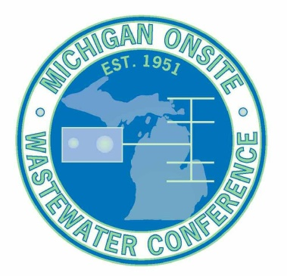
2020 Scholarship Application Form
The Michigan Onsite Wastewater Conference (MOWC) is offering a limited number of scholarships to help those people attend the conference that may otherwise not have access to the funding. Recently the MOWC committee approved an amount of $2,000 to be given away in the form of a 50% scholarship towards registration fees.
There are four types of scholarships being offered;
- Tuesday only
- Wednesday only
- Thursday only
- Full Conference
What’s covered by the scholarship is applied to the cost of the conference itself. Conference costs are as follows; $65 for individual days or $150 for the full conference. The scholarship does not cover the cost of the Hotel, Travel, Banquet or the workshop. The scholarship will cover 50% of the conference registration fee.
Select below which you are applying for;
Tuesday Only ($32.50)
Wednesday Only ($32.50)
Thursday Only ($32.50)
Full Conference ($75.00)
Please briefly describe the reason you are applying for the scholarship and how the education you hope to obtain from attending will help.
←Add your information here, text will wrap.
Submit this form to Joel Kwiatkowski via email to kwiatkowskij@baycounty.net and Karlyn Wickham via email to executiveofficer@msta.biz The deadline to submit this form is December 20, 2019.
You will be notified by email if you received the scholarship along with instructions on how to receive your discount. If you are not 100% positive you will be attending the conference please do not apply for this scholarship.
This is first come first serve until the approved amount of $2,000 is met so please apply soon if you would like to take advantage of this opportunity.

